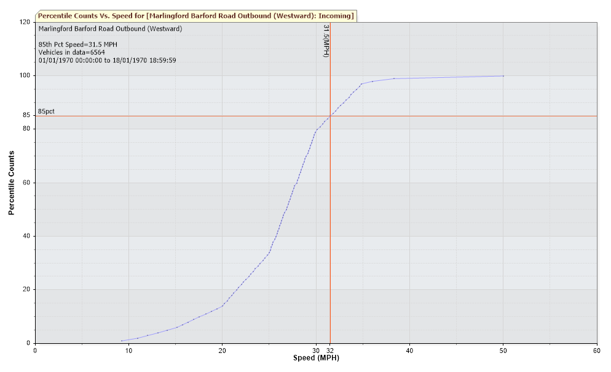
Note: The dataset was initiated on 19/5/22 and gathered on 6/6/22. There has been a power outage and accordingly this is an incomplete dataset.

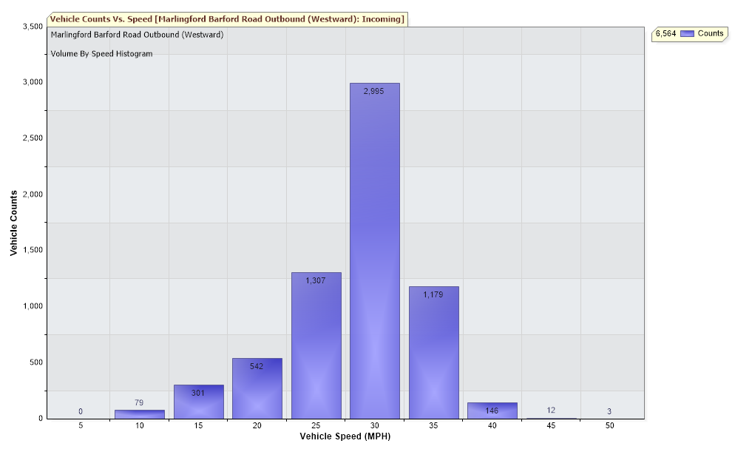
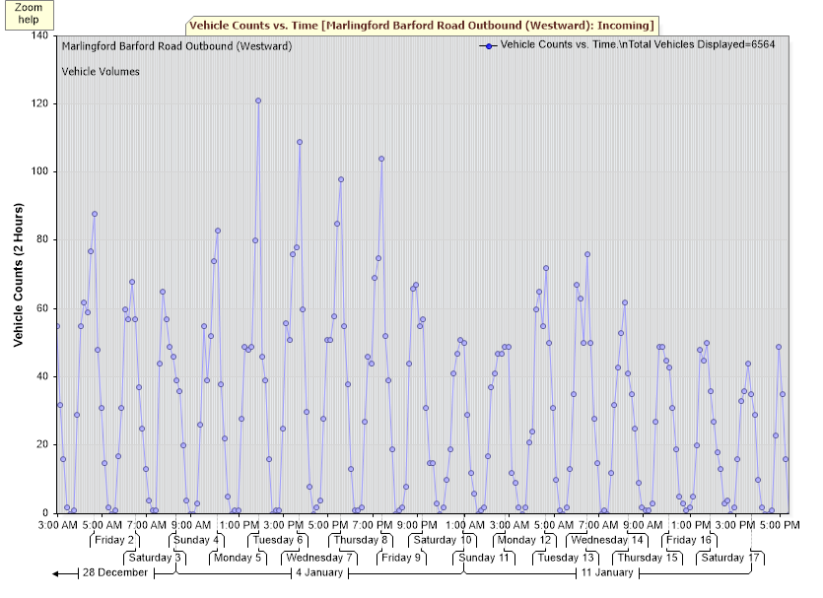

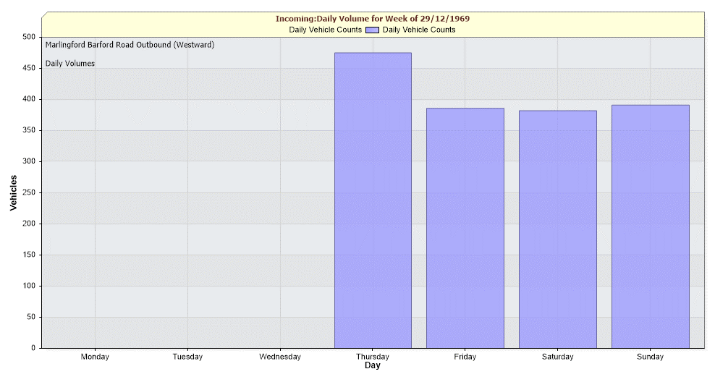
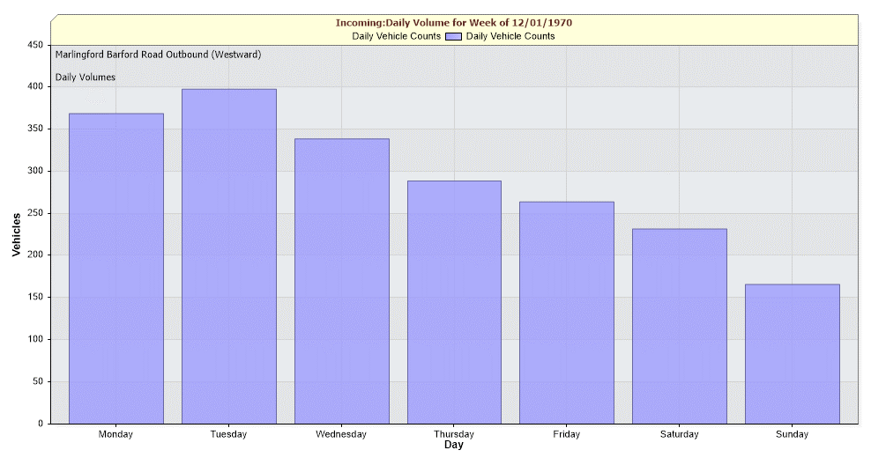
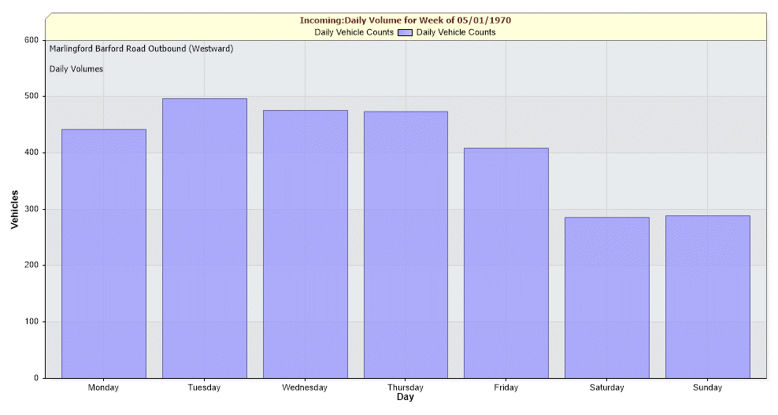

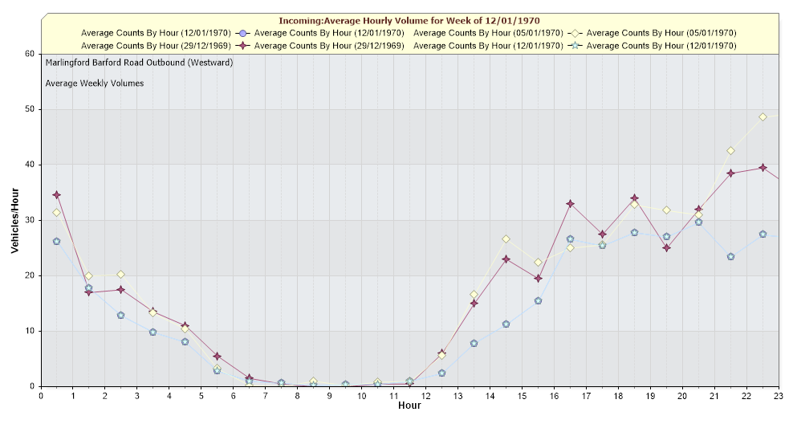
Note: The dataset was initiated on 19/5/22 and gathered on 6/6/22. There has been a power outage and accordingly this is an incomplete dataset.

